**Panels**

Adobe illustrator panels can be found on the right-hand side of the screen and by default has the a “Properties”, “Layers” and “Libraries” tabs in it. To the immediate left of the panel is a second panel which is dedicated to the comments.

**Comments Panel**

In Adobe Illustrator the user is able to use the comments panel to do two things

The **first** being that the user can create a link and send this link to other people to gather feedback of their design/s, all the feedback and comments will be kept in the comments panel. Within this comments panel the user is able to comment back to the users they sent the link to, resolve comments as well as update the link and design in order to continue the review cycle.

The **second** being that the user is able to save their designs to the “Creative Cloud” therefore allowing them to invite other users for a collaboration. On the shared document the user can send invitations, edits, reviews and comments.

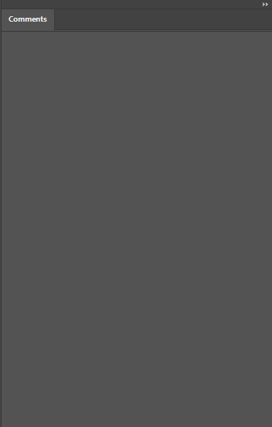

**Properties Panel**

in Adobe illustrator the user in able to us the “properties” panel to do 7 things.

The **first** feature that this panel provides is the ability to edit the units system as well as the number of artboards the user will work on.

The **second** being the ability to control the ruler feature as well as the grid that the user will be working on.

The **third** being the ability to control and edit the guides that are provided and chosen by the user to use during their design.

The **fourth** customization option is that the user is able to modify their “snap” option which will allow the user to snap to grid in many different ways and be able to be in their own preference.

The **fifth** option is to change other commonly used customization options within the preferences tab such as “Keyboard Increment” which allows you to change the distance your arrow keys make when moving an object.

The **sixth** option is the quick actions tab which allows the user to do things such as change the preferences of the document and also generate a Vector, which is a file format that creates points on a grid that makes the image appear closer.

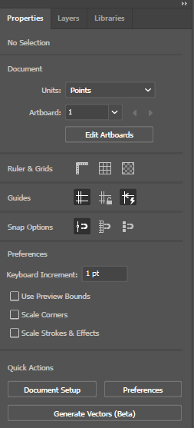

**Layers panel**

The Layers panel allows the user to modify and manage the layers they use within a design, they are also able to search for a specific layer and filter through several.

At the bottom of the page there are shortcuts.

* Current layer
* Save selection
* Collect for export
* Locate object
* Make/release clipping mask
* Create new sub layer
* Create new layer
* Delete selection



The three lines on the top right refers to the options and this feature allows the user to

* create new layers
* create new sublayers
* duplicate layers
* delete selections
* delete hidden layers
* edit layers in their options menus
* make or break a clipping mask
* enter/exit  isolation mode
* locate object
* merge selection
* flatten artwork
* collect in new layer
* sequence layers
* build layer
* reverse order
* Template
* hide all layers
* outline all layers
* lock all layers
* paste remembers layers
* panel options

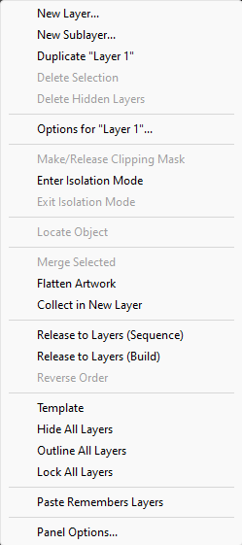

**Libraries panel**

In the libraries panel the user is able save certain elements to a library to ensure that themselves and their team are able to access the same elements, you are able to create your own and share them as well as receive libraries from others as well as find ready made libraries made by adobe for any user to use.

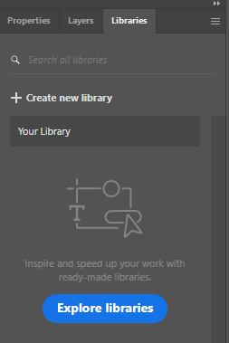

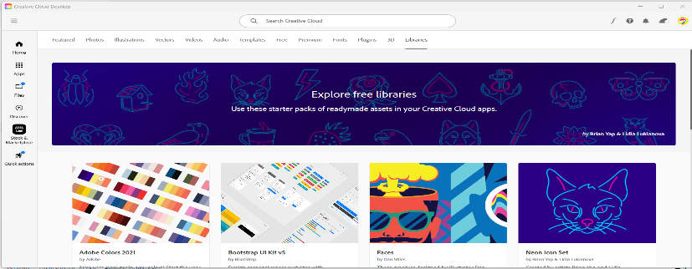

At the bottom of the page there are shortcuts

* Save (all up to date)
* Add libraries



The three lines on the top right refers to the options and this feature allows the user to

* create new library
* import library
* view deleted items
* learn more
* what’s new
* provide feedback

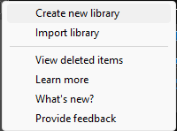

**Summary of the left-hand side of the toolbar in *Adobe Illustrator***



Selection Tool (V) - Selects an entire object or group

Pen Tool (P) - Creates paths by identifying anchor points and curves

Rectangle Tool (M) - Draws squares and rectangles

Type Tool (T) - Type text at a point or in a container

Eraser Tool (Shift + E) - Removes parts of a path of shape

Gradient Tool (G) - Creates gradual blends between colours

Eyedropper Tool (I) - Copy and apply appearance attributes between objects

Blend Tool (W) - Morph shapes and colours between two or more objects

Zoom Tool (Z) - Zooms in and out of the canvas and artboard

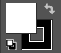

Fill and Stroke (X) - Set interior and outline colour, pattern or gradient

**Shortcuts:**

**Tools Shortcuts:**

Selection V

Direct Selection A

Lasso Tool Q

Pen P

Anchor Point Shift + C

Curvature Shit + ~

Rectangle M

Ellipse L

Line Segment \

Paintbrush B

Blob Brush Shift + B

Pencil Tool 'N

Type T

Rotate R

Scale S

Reflect O

Eraser Shift + E

Scissors C

Shape Builder Shift + M

Gradient G

Mesh U

Eyedropper I

Width Shift + W

Blend W

Artboard Shift + O

Zoom Z

Hand H

Rotate View Shift + H

**File Shortcuts:**

New Ctrl + 'N

New From Template Ctrl + Shift + 'N

Open Ctrl + O

Browse In Bridge Alt + Ctrl + O

Close Ctrl + W

Close All Alt + Ctrl + W

Save Ctrl + S

Save As Shift + Ctrl + S

Save A Copy Alt + Ctrl + S

Place Shift + Ctrl + P

Generate Vectors Alt + Shift + Ctrl + G

Document Setup Alt + Ctrl + P

File Info Alt + Shift + Ctrl + I

Print Ctrl + P

Exit Ctrl + Q

**Edit Shortcuts:**

Undo Ctrl + Z

Redo Shift + Ctrl + Z

Cut Ctrl + X

Copy Ctrl + C

Paste Ctrl + V

Paste In Front Ctrl + F

Paste In Back Ctrl + B

Paste In Place Shift + Ctrl + V

Paste On All Artboards Alt + Shift + Ctrl + V

Paste Without Formatting Alt + Ctrl + V

Colour Settings Shift + Ctrl + K

Keyboard Shortcuts Alt + Shift + Ctrl + K

**Object Shortcuts:**

Group Ctrl + G

Ungroup Shift + Ctrl + G

Unlock All Alt + Ctrl + 2

Show All Alt + Ctrl + 3

Type Shortcuts:

Create Outlines Ctrl + Shift + O

Show Hidden Characters Alt + Ctrl + I

**Select Shortcuts:**

All Ctrl + A

All On Active Artboard Alt + Ctrl + A

Deselect Shift + Ctrl + A

Reselect Ctrl + 6

Next Object Above Alt + Ctrl + ]

Next Object Below Alt + Ctrl + [

**Effect Shortcuts:**

Apply Last Effect Shift + Ctrl + E

Last Effect Alt + Shift + Ctrl + E

**View Shortcuts:**

Outline Ctrl + Y

Preview On CPU Ctrl + E

Overprint Preview Alt + Shift + Ctrl + Y

Pixel Preview Alt + Ctrl + Y

Zoom In Ctrl + +

Zoom Out Ctrl + -

Fit Artboard In Window Ctrl + 0

Fit All In Window Alt + Ctrl + 0

Hide Bounding Box Shift + Ctrl + B

Show transparency grid Shift + Ctrl + D

Actual size Ctrl + 1

Hide gradient Annotator Alt + Ctrl + G

Hide edges Ctrl + H

Smart guides Ctrl + U

Hide artboards Shift + Ctrl + H

Hide template Shift + Ctrl + W

Hide text Threads Shift + Ctrl + Y

Show grid Ctrl + “

Snap to grid Shift + Ctrl + “

Snap to point Alt + Ctrl + “

**Window Shortcuts:**

Brushes F5

Colour F6

Colour guide Shift + F3

Gradient Ctrl + F9

Graphic Style Shift + F5

Info Ctrl + F8

Layers F7

Pathfinder Shift + Ctrl + F9

Stroke Ctrl + F10

Symbols Shift + Ctrl + F11

Transform Shift + F8

Transparency Shift + Ctrl + F10

**Help Shortcuts:**

Illustrator Help F1

**Control Pannel:**

**Select Menu:**

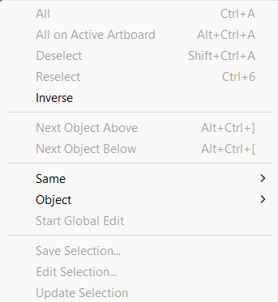

**All:** Select > All is used to select all elements on all artboards that are currently in the illustrator file.

**All on active artboard**: Select > All on active artboard is used to select all the elements that are on the current active artboard.

**Deselect**: Select > Deselect is used to deselect any currently selected elements in Illustrator.

**Reselect**: Select > Reselect is used to reselect a previously selected element.

**Inverse:** Select > Inverse is used to select everything that is not currently selected (The opposite of the selection).

**Next Object Above**: Select > Next object above is used to select the element above the currently selected element in the layers panel.

**Next Object Below**: Select > Next object below is used to select the element below the currently selected element in the layers panel.

**Same**: Select > Same is used to select elements with the same colour, appearance, opacity, font, etc.

**Object**: Select > Object is used to select all brush strokes, stray points, text objects, etc.

**Start global edit**: Select > Start global edit is used to change the appearance of all similar element in the Illustrator file.

**Save Selection**: Select > Save selection is used to save the currently active selection to access it again later if needed.

**Edit Selection**: Select > Edit selection is used to make changes to the current selection.

**Update Selection**: Select > Update Selection is used to rename or delete a saved selection.

File:

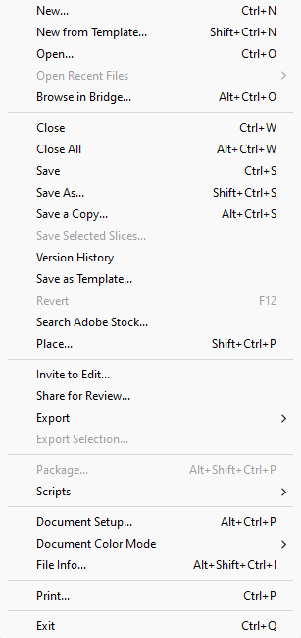

Ctrl + N – New, this shortcut helps you to create a new project inside of Adobe Illustrator

Shift + Ctrl + N – New from Template, you can use this tool to import a certain shape from a pre-saved image

Ctrl + O – Open, you can use this tool to open e desired file into illustrator

Alt + Ctrl + O – Browse in Bridge, this tool opens Adobe Bridge which you can use toto organize files by renaming a group of them at once, assigning coloured labels or star ratings assigned to files from the respective Adobe software suite, edit embedded or associated XMP and IPTC Information Interchange Model metadata, or sort or categorize them based on their metadata

Ctrl + W – Close, you can use this tool to close your file that is currently open

Alt + Ctrl + W – Close All, this tool closes all files that are currently open even if you aren’t busy using them

Ctrl + S – Save, this tool saves all of your edits that you have made in your file

Shift + Ctrl + S - The "save as" feature allows users to create a new file based on an existing one. It saves a copy of the original file under a different name or in a different location, preserving the original file while allowing modifications to the new version

Alt + Ctrl + S – Save a Copy, this tool saves a copy of your current file under the same name

Version History - Version history includes the dates each version was edited, how long that version was in place for, and what changed

Save as Template - A template is a document type that creates a copy of itself when you open it. For example, a business plan is a common document that is written in Word. Instead of creating the structure of the business plan from scratch, you can use a template with predefined page layout, fonts, margins, and styles.

Search Adobe Stock – This tool opens Adobe Stock and enables the user to search through the site for their preferred templates and images

Shift + Ctrl + P – Place, so basically you have a document open in illustrator for example and you want to place a different existing file into that document you can either keep the placed file linked

Invite to Edit – this tool enables you to give other people editing permissions so that they can edit your file

Share for Review - The Share for Review feature simplifies sharing and gathering feedback on your creative work. This feature lets you collaborate seamlessly with teammates and stakeholders directly from your Creative Cloud app

Export –



Alt + Ctrl + E – Export for Screens, Illustrator runs the export process in the background by default. It helps you save a lot of time and improves productivity

Export As - In the option box, choose to export Active or All geometry

Alt + Shift + Ctrl + S – Save for Web (Legacy), Validity of your image there are a number of presets. You can use if you come here, you can see you've got the option of gif jpeg or png

Scripts –

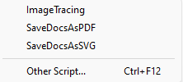

ImageTracking - Tracking is the process of loosening or tightening a block of text.

SaveDocsAsPDF – Saves your file as a PDF

SaveDocsAsSVG – Saves file as SVG

Ctrl + f12 – Other Script, saves file as other script

Alt + Ctrl + P - Document Setup, Change the units or bleed settings, and then click OK. Or click Preferences in the Properties panel to quickly access and change any of the Illustrator application settings to your liking

Document colour setup –



Changes the files colour settings

Alt + Shift + Ctrl + I – File info

Ctrl + P – Print

Ctrl + Q - Close

Edit:

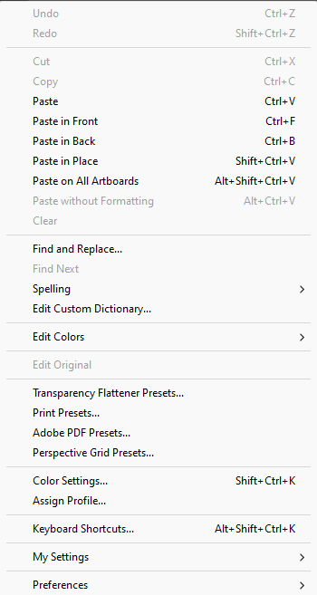

Ctrl + Z – Undo, used to reverse the last action you made

Shift + Ctrl + Z – Redo, used to reverse the undo action

Ctrl + X – Cut, the cut command is used to remove text or images from the screen you are currently working on

Ctrl + C – Copy, it copies the text or image you have selected and stores is on your virtual clipboard

Ctrl + V – Paste, used to paste information into a computer document

Ctrl + F – Paste in Front, used to paste in front of selected layer

Ctrl + B – Paste in Back, used to paste behind selected layer

Shift + Ctrl + V – Paste in Place, will paste the object at the top of the layer hierarchy, again, in the exact same position you copied it from

Alt + Shift + Ctrl + V – Paste on All Artboards, will paste the object on all artboards, including the one you removed it from, in the same relative position on the artboard

Alt + Ctrl + V – Paste Without Formatting, dimmed if you paste text from another application when Text Only is selected in Clipboard Handling Preferences

Clear - When the Appearance box appears, click on the effect you wish to remove

Find and Replace - it finds similar colours and fonts, but you can choose to find geometries, blending modes, lengths and so much more

Find Next –

Spelling –



Edit Custom Dictionary - provide the simple but powerful ability to match a list of words or phrases

Edit Colours –

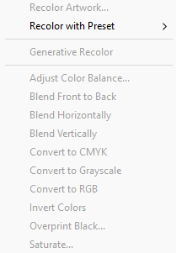

Edit Original - lets you open most graphics in the application in which you created them so that you can modify them as necessary

Transparency Flattener Preset - Flattening divides transparent artwork into vector-based areas and rasterized areas

Print Presets - Using print presets is a fast, reliable way to print jobs that require consistently accurate settings for many options in the Print dialog box

Adobe PDF Presets - Changing any option causes the name of the preset to change to Custom

Perspective Grid Presets - allows interaction with the grid planes, cell size, and other aspects of the grid without affecting the artwork

Shift + Ctrl + K – Colour Settings, reconciles the colour differences between the different devices

Assign Profile, dictate the colour gamut that various devices will display

Alt + Shift + Ctrl + K – Keyboard Shortcuts, shows you all of your keyboard shortcuts

Effects:

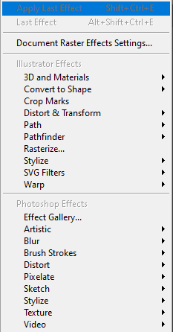

Shift + Ctrl + E – Apply Last Effect, uses your last effect that you selected

Alt + Shift + Ctrl + E – Last Effect, shows you the last effect that you used

Document Raster Effect Settings - adjust the resolution of those effects

Illustrator effects:

3D and Materials –

Convert to Shape –

Crop Marks –

Distort and Transform –

Path –

Pathfinder –

Rasterize –

Stylize –

SVG Filters –

Warp –

Photoshop Effects:

Artistic effects –

Colored Pencil

Draws an image using colored pencils on a solid background. Important edges are retained and given a rough crosshatch appearance; the solid background color shows through the smoother areas.

Cutout

Portrays an image as though it were made from roughly cut-out pieces of colored paper. High-contrast images appear as if in silhouette; colored images are built up as if from several layers of colored paper.

Dry Brush

Paints the edges of the image using a dry-brush technique (between oil and watercolor). The effect simplifies an image by reducing its range of colors.

Film Grain

Applies an even pattern to the shadow tones and midtones of an image. A smoother, more saturated pattern is added to the image’s lighter areas. This effect is useful for eliminating banding in blends and visually unifying elements from various sources.

Fresco

Paints an image in a coarse manner using short, rounded strokes as if hastily applied.

Neon Glow

Adds various types of glows to the objects in an image. This effect is useful for colorizing an image while softening its look. To select a glow color, click the glow box and select a color from the color picker.

Paint Daubs

Lets you choose from various brush sizes (from 1 to 50) and types for a painterly effect. Brush types include simple, light rough, light dark, wide sharp, wide blurry, and sparkle.

Palette Knife

Reduces detail in an image to give the effect of a thinly painted canvas that reveals the texture underneath.

Plastic Wrap

Coats the image as if in shiny plastic, accentuating the surface detail.

Poster Edges

Reduces the number of colors in an image according to the Posterization value you set; then finds the edges of the image and draws black lines on them. Broader areas of the image have simple shading, while fine, dark detail is distributed throughout the image.

Rough Pastels

Makes an image appear as if stroked with colored pastel chalk on a textured background. In areas of bright color, the chalk appears thick with little texture; in darker areas, the chalk appears scraped off to reveal the texture.

Smudge Stick

Softens an image using short diagonal strokes to smudge or smear the darker areas of the images. Lighter areas become brighter and lose detail.

Sponge

Creates images with highly textured areas of contrasting color as if painted with a sponge.

Underpainting

Paints the image on a textured background, and then paints the final image over it.

Watercolor

Paints the image in a watercolor style, simplifying details, and using a medium brush loaded with water and color. Where significant tonal changes occur at edges, the effect saturates the color.

Blur effects –

Gaussian Blur

Quickly blurs a selection by an adjustable amount. This effect removes high-frequency detail and can produce a hazy effect.

Radial Blur

Simulates the soft blur created by a zooming or rotating camera. Choose Spin to blur along concentric circular lines, and then specify a degree of rotation. Choose Zoom to blur along radial lines, as if zooming in or out of the image, and specify an amount from 1 to 100. Blur quality ranges from Draft for the fastest but grainy results to Good and Best for smoother results, which are indistinguishable except on a large selection. Specify the origin of the blur by dragging the pattern in the Blur Center box.

Smart Blur

Blurs an image with precision. You can specify a radius, a threshold, and a blur quality. The Radius value determines the size of the area searched for dissimilar pixels. The Threshold value determines how dissimilar the pixels must be before they are affected. You also can set a mode for the entire selection (Normal) or for the edges of color transitions (Edge Only and Overlay). Where significant contrast occurs, Edge Only applies black-and-white edges, and Overlay Edge applies white

Brush Strokes effects –

Accented Edges

Accentuates the edges of an image. When the Edge Brightness control is set to a high value, the accents resemble white chalk. When it is set to a low value, the accents resemble black ink.

Angled Strokes

Repaints an image using diagonal strokes. The lighter areas of the image are painted in strokes going in one direction, while the darker areas are painted in strokes going the opposite direction.

Crosshatch

Preserves the details and features of the original image while adding texture and roughening the edges of the colored areas in the image with simulated pencil hatching. The Strength option controls the number of hatching passes (from 1 to 3).

Dark Strokes

Paints dark areas of an image closer to black with short strokes, and paints lighter areas of the image with long, white strokes.

Ink Outlines

Redraws an image with fine narrow lines over the original details, in pen-and-ink style.

Spatter

Replicates the effect of a spatter airbrush. Increasing the values of the options simplifies the overall effect.

Sprayed Strokes

Repaints an image using its dominant colors with angled, sprayed strokes of color.

Sumi‑e

Paints an image in Japanese style as if with a wet brush full of black ink on rice paper. The effect is soft, blurry edges with rich blacks.

Distort effects

The Distort commands can be very memory-intensive. They are raster-based and use the document’s raster effects settings whenever you apply the effect to a vector object.

Diffuse Glow

Renders an image as if it were being viewed through a soft diffusion filter. The effect adds see-through white noise to an image, with the glow fading from the center of a selection.

Glass

Makes an image appear as if it were being viewed through different types of glass. You can choose a preset glass effect or create your own glass surface using a Photoshop file. You can adjust scaling, distortion, and smoothness settings, as well as texturizing options.

Ocean Ripple

Adds randomly spaced ripples to the artwork, making the artwork look as if it were under water.

Pixelate effects –

Color Halftone

Simulates the effect of using an enlarged halftone screen on each channel of the image. For each channel, the effect divides the image into rectangles and replaces each rectangle with a circle. The circle size is proportional to the brightness of the rectangle.

To use the effect, enter a value in pixels for the maximum radius of a halftone dot (from 4 to 127), and enter a screen-angle value (the angle of the dot relative to the true horizontal) for one or more channels. For Grayscale images, use only channel 1. For RGB images, use channels 1, 2, and 3, which correspond to the red, green, and blue channels. For CMYK images, use all four channels, which correspond to the cyan, magenta, yellow, and black channels.

Crystallize

Clumps colors into polygon shapes.

Mezzotint

Converts an image to a random pattern of black-and-white areas, or of fully saturated colors in a color image. To use the effect, choose a dot pattern from the Type pop-up menu in the Mezzotint dialog box.

Pointillize

Breaks up the color in an image into randomly placed dots, as in a pointillist painting, and uses the background color as a canvas area between the dots.

Sharpen effect –

Unsharp Mask

Finds the areas in the image where significant color changes occur and sharpens them. Use the Unsharp Mask effect to adjust the contrast of edge detail and produce a lighter and darker line on each side of the edge. This effect emphasizes the edge and creates the illusion of a sharper image.

Sketch effects –

Bas Relief

Transforms an image to appear carved in low relief and lit to accent the surface variations. Dark areas of the image are colored black; light colors are colored white.

Chalk & Charcoal

Redraws an image’s highlights and midtones with a solid midtone gray background drawn in coarse chalk. Shadow areas are replaced with diagonal charcoal lines. The charcoal is drawn in black, the chalk in white.

Charcoal

Redraws an image to create a posterized, smudged effect. Major edges are drawn boldly while midtones are sketched using a diagonal stroke. Charcoal is colored black; the paper is colored white.

Chrome

Treats the image as if it were a polished chrome surface. Highlights are high points and shadows are low points in the reflecting surface.

Conté Crayon

Replicates the texture of dense dark and pure white Conté crayons on an image. The Conté Crayon effect uses black for dark areas and the white for light areas.

Graphic Pen

Uses fine, linear ink strokes to capture the details in the original image. The effect replaces color in the original image using black for ink and white for paper. This command is especially striking with scanned images.

Halftone Pattern

Simulates the effect of a halftone screen while maintaining the continuous range of tones.

Note Paper

Creates an image that appears to be constructed of handmade paper. The effect simplifies an image, and combines the effect of the Grain command (Texture submenu) with an embossed appearance. Dark areas of the image appear as holes in the top layer of paper surrounded by white.

Photocopy

Simulates the effect of photocopying an image. Large areas of darkness tend to copy only around their edges; midtones fall away to either solid black or white.

Plaster

Molds an image as if from plaster, and then colorizes the result using black and white. Dark areas are raised; light areas are sunken.

Reticulation

Simulates the controlled shrinking and distorting of film emulsion to create an image that appears clumped in the shadow areas and lightly grained in the highlights.

Stamp

Simplifies the image to appear stamped with a rubber or wood stamp. This command is best used with black-and-white images.

Torn Edges

Reconstructs the image as ragged, torn pieces of paper, and then colorizes the image using black and white. This command is useful for images consisting of text or high-contrast objects.

Water Paper

Uses blotchy daubs that appear painted onto fibrous, damp paper, causing the colors to flow and blend.

Stylize effect –

Glowing Edges

Identifies the edges of color and adds a neon-like glow to them

Texture effects –

Craquelure

Paints an image onto a high-relief plaster surface, producing a fine network of cracks that follow the contours of the image. Use this effect to create an embossing effect with images that contain a broad range of color or grayscale values.

Grain

Adds texture to an image by simulating different kinds of grain—regular, soft, sprinkles, clumped, contrasty, enlarged, stippled, horizontal, vertical, or speckle. For more information on using these texturizing options, see Use texture and glass surface controls.

Mosaic Tiles

Draws the image as if it were made up of small chips or tiles and adds grout between the tiles. (In contrast, the Pixelate > Mosaic command breaks up an image into blocks of different-colored pixels.)

Patchwork

Breaks up an image into squares filled with the predominant color in that area of the image. The effect randomly reduces or increases the tile depth to replicate highlights and shadows.

Stained Glass

Repaints an image as single-colored adjacent cells outlined in the foreground color.

Texturizer

Applies a texture you select or create to an image.

Video effects –

De‑Interlace

Smooths moving images captured on video by removing either the odd or even interlaced lines in a video image. You can choose to replace the discarded lines by duplication or interpolation.

NTSC Colors

Restricts the gamut of colors to those acceptable for television reproduction to prevent oversaturated colors from bleeding across television scan lines.